**Relational Data Model – Order Entry**

Edward Galligan III

Colorado State University – Global Campus

MIS407 – Database Concepts

Dr. Kadri Brogi

January 24, 2021

**Relational Data Model – Order Entry**

Below is a screenshot of the expanded Customer table and SQL code.

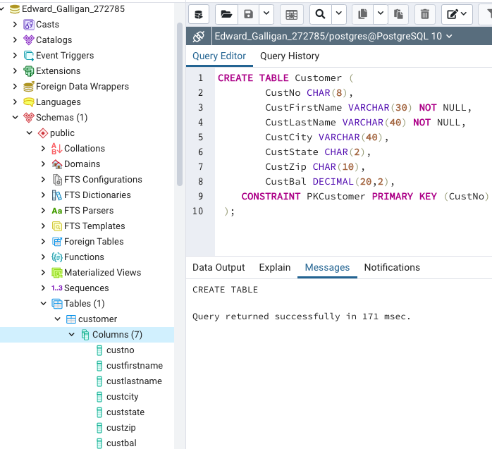

Below is a screenshot of the expanded Employee table and SQL code.

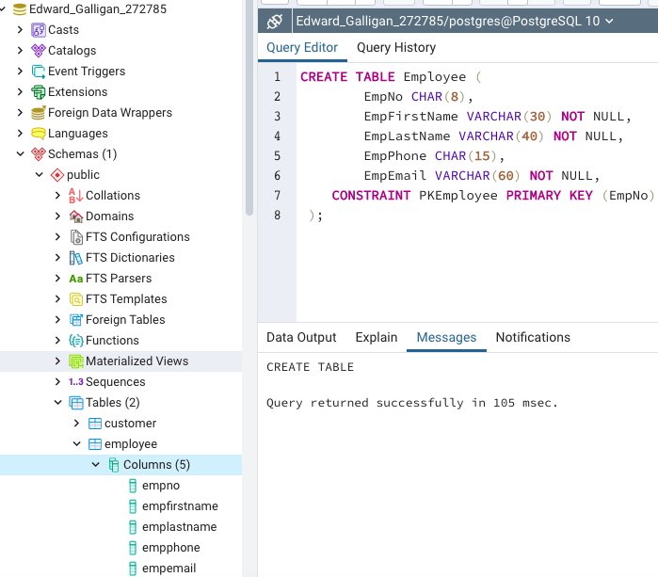

Below is a screenshot of the expanded Order table and SQL code.

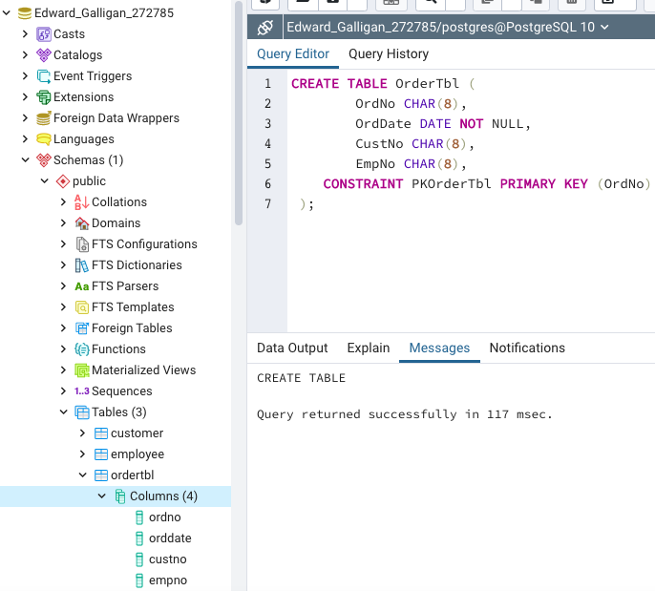

Below is an Entity Relationship Diagram showing the primary and foreign keys and parent and child tables.



**Challenges**

The main challenge that confused me was executing a query to create a table and not seeing it show up in the browser. After dropping and recreating the table multiple times and still not seeing it show up in the browser and trying different things to see if I could get it to show up, I realized that if I right clicked in the browser, I could refresh the browser, and the created table would show up in the browser. I also had to reference the last module to refresh my memory on how to create a new database and open the query tool.